Lesson 04 XAS Resource Workbook

**Interpreting Data**

**Charles A. Cardot and Gerald T. Seidler**

*All lessons and all versions can be found at* [*https://github.com/XASResourceWorkbook/XASResourceWorkbook*](https://github.com/XASResourceWorkbook/XASResourceWorkbook)

*This work is licensed under* ***CC BY-NC-SA 4.0***

**

Version History:

1.0 *Month Year*: C.A. Cardot, G.T. Seidler

Lesson 04 XAS Resource Workbook

**Interpreting Data**

**Suggested Introductory Reading**

* Suggested Reading 1
* Suggested Reading 2

**Overview and Advanced Reading**

Intro Paragraph

## **I. XANES Data**

**Educational Goals**:

Below is a graph showing the normalized absorption coefficients of the K edge for various Vanadium oxides.

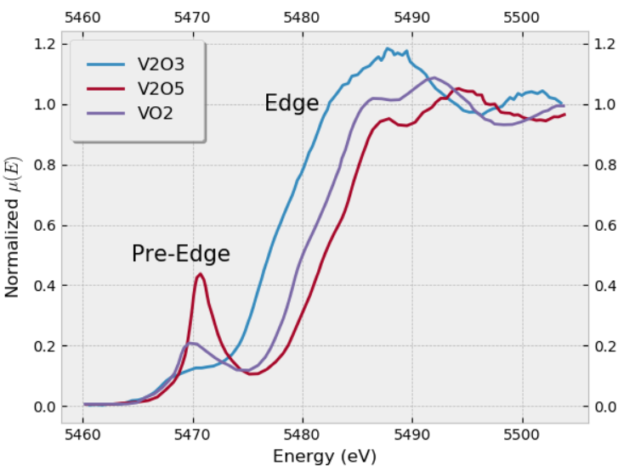

* 1. Explain how the data helps you distinguish between the three oxides. Why are the edges shifted?

* 1. Use the materials project database, <https://materialsproject.org/>, to look up the crystal structure for each Vanadium oxide. For each structure, how many V are in the unit cell? Describe (generally) how crystallographically equivalent the different V sites are for each oxide. Feel free to use the cif file for a symmetrized unit cell to get a better idea of the symmetries that are present. Are their local coordinations equivalent?
  2. Make a sketch of the immediate V coordination for each of the oxides, showing and labeling the number of nearest neighbors and the coordination geometry. Feel free to specify just the idealized geometry of the structure.
  3. Based on the details of the V coordination geometry from your sketches, for which of the oxides are the V 3d-derived orbitals going to be the most atomic-like? For which oxide will the 3d-derived orbitals have the strongest p-type character?
  4. How does the p-type character of the 3d-derived orbitals influence the strength of the 3d pre-edge feature?

* 1. Compare the XAFS spectrum from Vanadium metal to that of the oxides above, what are the key differences?

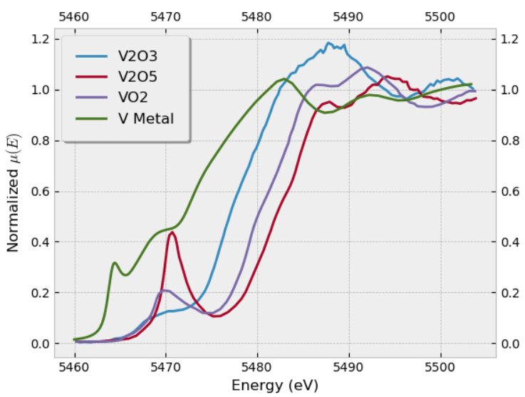

## **II. k-space**

**Educational Goals**:

* 1. What are the typical units for k-space? What do the units of k-space tell us?

* 1. For the XAFS spectrum of Fe (metal) the K edge at $E_{o}≈7100 eV$. Fill in the first table below for values of E(k) steps of 1 inv ang. Then fill in the second table with k(E) for 50 eV steps above the edge. Be careful, the k values we are interested in are the ones associated with the photoelectron, which has energy E – EBinding. A few values are included in the table so that you can check your math.

|  |  |  |  |  |  |  |  |  |  |  |
| --- | --- | --- | --- | --- | --- | --- | --- | --- | --- | --- |
| k (Å-1) | 0 | 1 | 2 | 3 | 4 | 5 | 6 | 7 | 8 | 9 |
| E (eV) | 7100 |  |  |  |  |  |  |  | 7344 |  |

|  |  |  |  |  |  |  |  |  |  |  |
| --- | --- | --- | --- | --- | --- | --- | --- | --- | --- | --- |
| E (eV) | 7100 | 7150 | 7200 | 7250 | 7300 | 7350 | 7400 | 7450 | 7500 | 7550 |
| k (Å-1) |  | 3.621 |  |  |  |  |  |  |  | 10.863 |

* 1. Based on the tables you made in the previous problem, if features are equally spaced in k, how are they spaced in E, and vice versa?
  2. We know that for a 1D particle in a box the bound states will correspond to the states where the particle has wavelengths equal to an integer or half-integer multiple of the length of the box. Assume a photoelectron of mass m is excited out of an atom and into a box of length L. Make a sketch showing how the values E and k change with the state the system is in (number of n half-integer wavelengths).

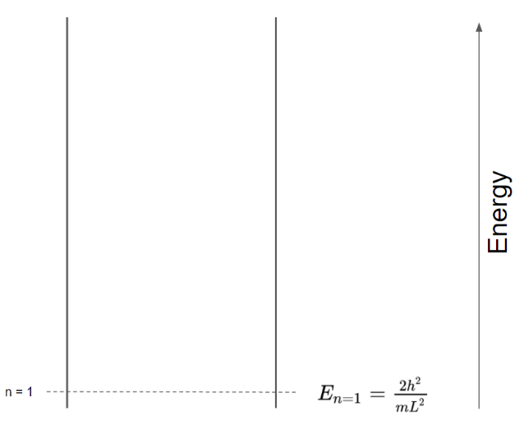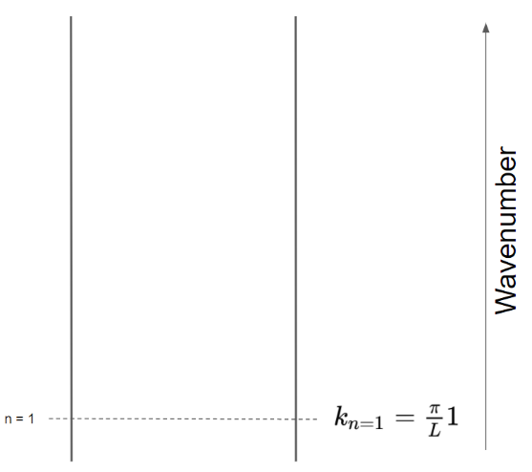

* 1. Now plot a density of states for energy and for momentum. For energy, this will be a plot where the x-axis is energy and there are delta functions at each energy where a particle-in-the-box state exists, and analogously for k.

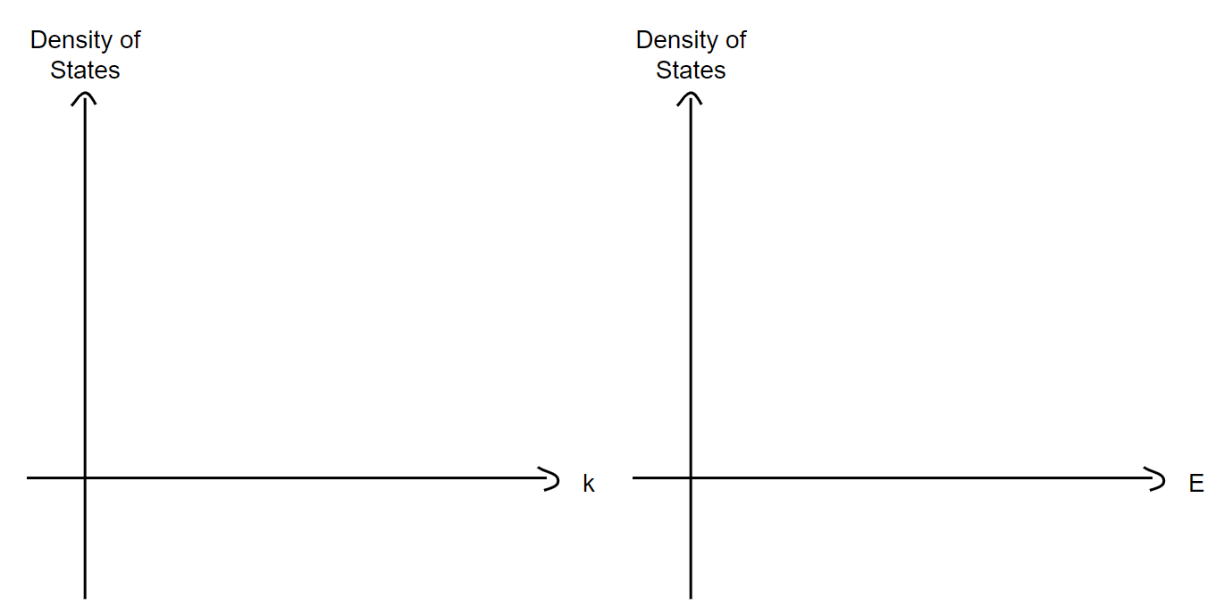

* 1. Starting with your density of states plots, which one has a simpler Fourier transform? What is the meaning of the Fourier transform of the k-based density of states?
  2. How is the diatomic molecule case conceptually analogous to the 1D particle in the box model?
  3. Below *roughly* sketch what you expect the oscillation component of the EXAFS to be in E and in k for a simple diatomic molecule in the gas phase. For simplicity, set the edge jump to zero, $∆μ =0$.

Sketch for k: Sketch for E:

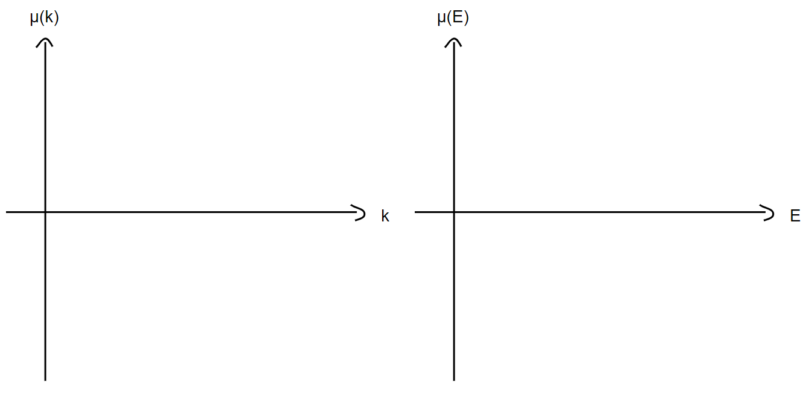

* 1. Now *roughly* sketch what you would expect to see for the Fourier transform of the EXAFS oscillations in k-space.

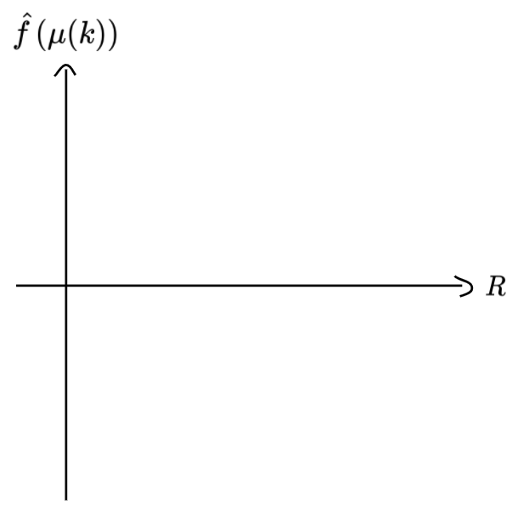

* 1. Consider the photoelectron which gets scattered in the diatomic molecule. What if when the photoelectron scatters it picked up a small phase shift. What effect does that have on the position of the peak(s) in the Fourier transform plot from the past problem?
  2. Below is the $χ(R)$ (fourier transformed $χ(k)$) data for three different structures. Identify which bonds/paths the major peaks correspond to. Be aware that the position of the peaks may not exactly equal the bond/path distance in the actual structure.

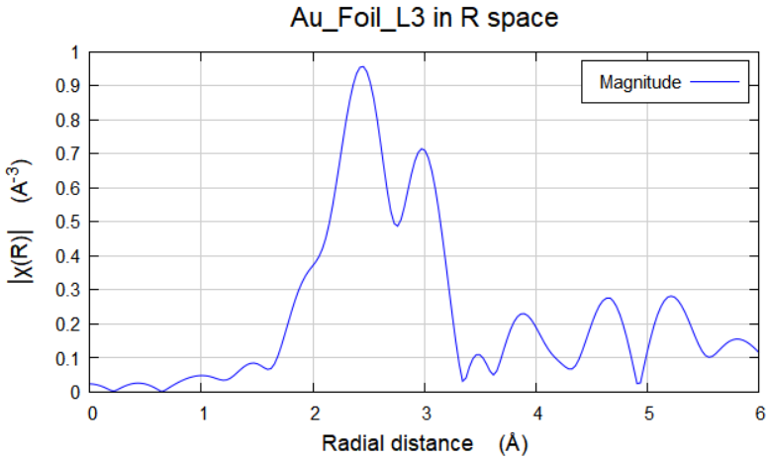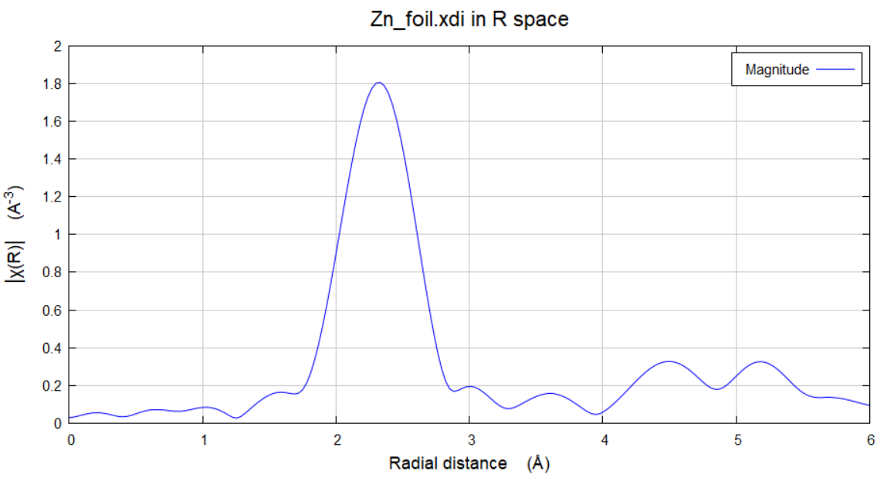

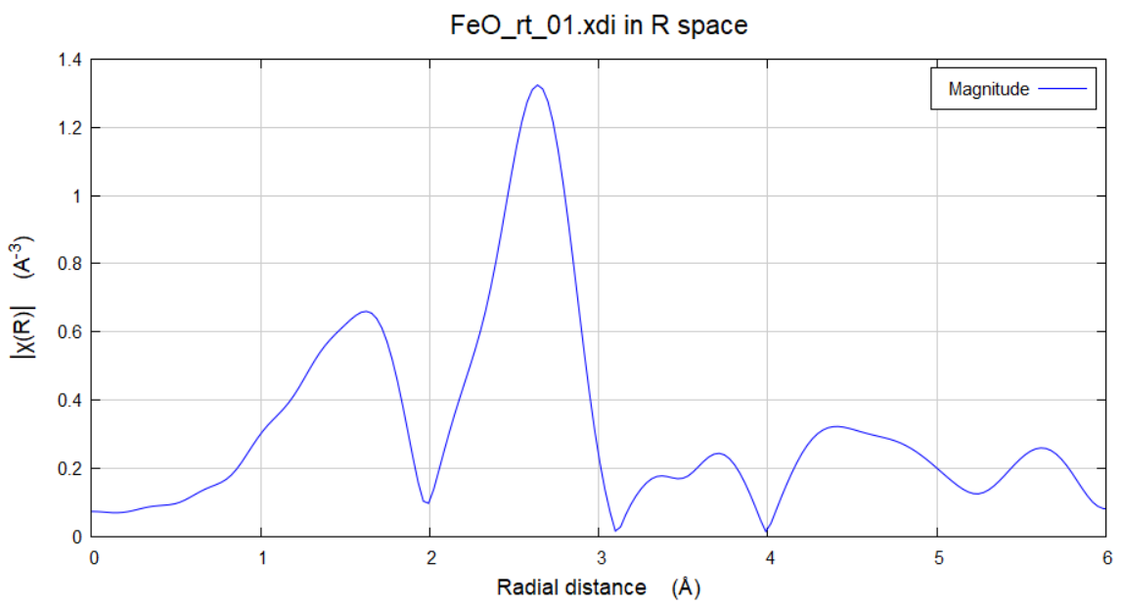

* 1. You should have noted that the true radial distances did not directly correspond to the actual distances between atoms. Why was this? What part of the EXAFS equation is this connected to?